Wonderland skript.

In first sence and in trailer of overall tail.

Alice… a voce of fram calls. you see lips and a tree on a far awy english meto

where are you ALice….you see lips and the wind blow an english ladies gound…

you see a young asian girl...with a blue dress.and big eyes lift here is from a mistick book.

she hide the book...over her sister! alice yes

alice you are going to be late for your wedding…

see turn to see a white flash only to turn to chech the glime of a pocket watch….

the rest of the trailer will show the 8 acts of the story stating from my storyboard…

the meat of the story as a game with mechanics will be determined by a set number of developers. this developers will be payed by the kickstarter for the game to work based of the geven requirements for each role.

those requirements will be to design a unique fun game mechanic to tell a story and bring the game alive using the established lore and given the same game engine.

Mysql comes first

We will teach the player to record infomation about the game to pull up coralations and find answers for them selfs

even lvl up and gain hidden aturbutes, wizords can find answers to how to beat bosses

new Ideas are great. but data can be research to find the root of any problem or solution. create references and understand patterns in the world around you.

Mission 1

Design a game that explains the basic interaction with a mysql database….

Build your own UI game machanic

Starter kit

Developed kit

Mod Kit

Quest Wireframe

**Legendary implementation!**

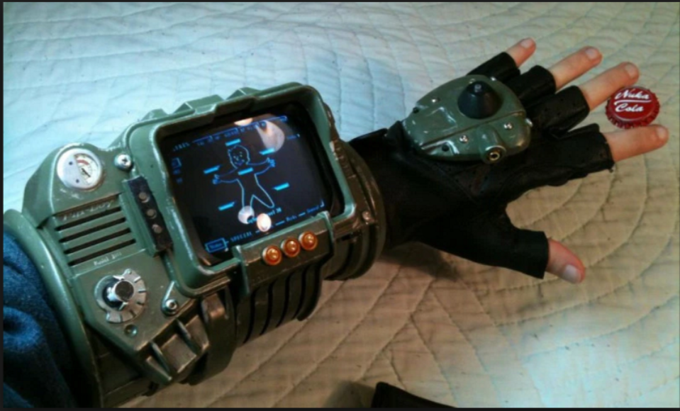

mmorpg inventory management

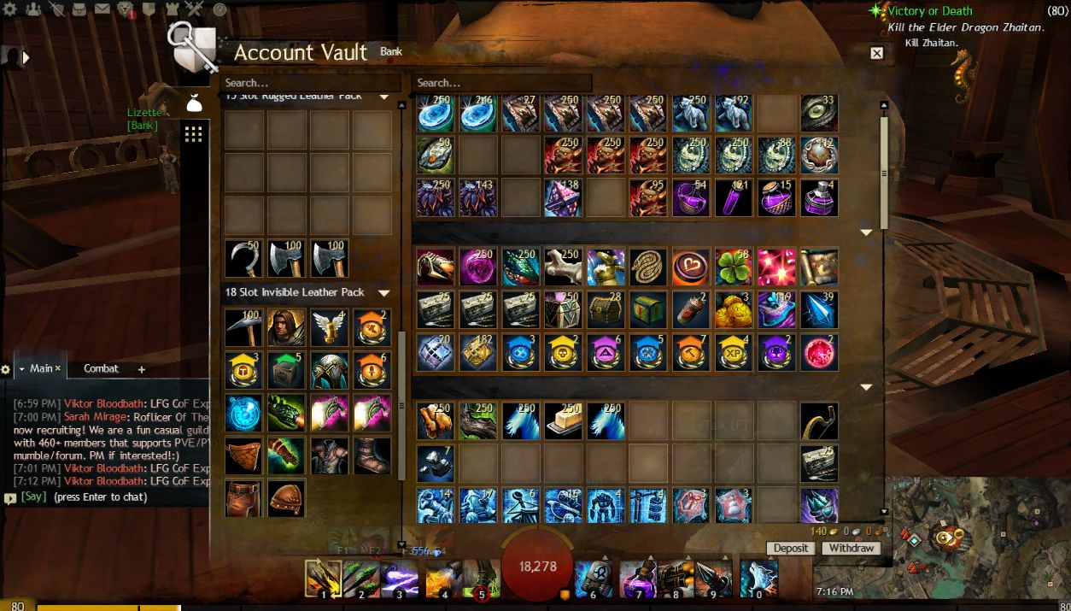

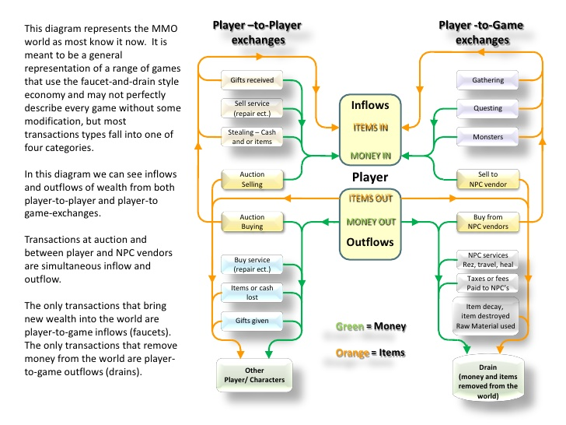

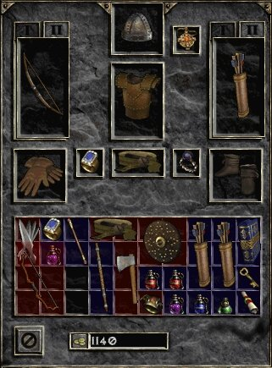  
**mmorpg economy system**

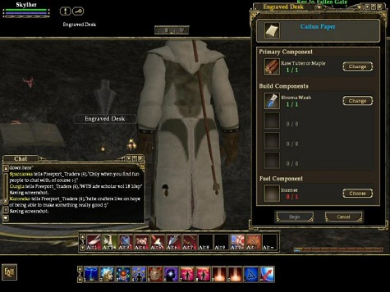

craft system

uniqe to each class

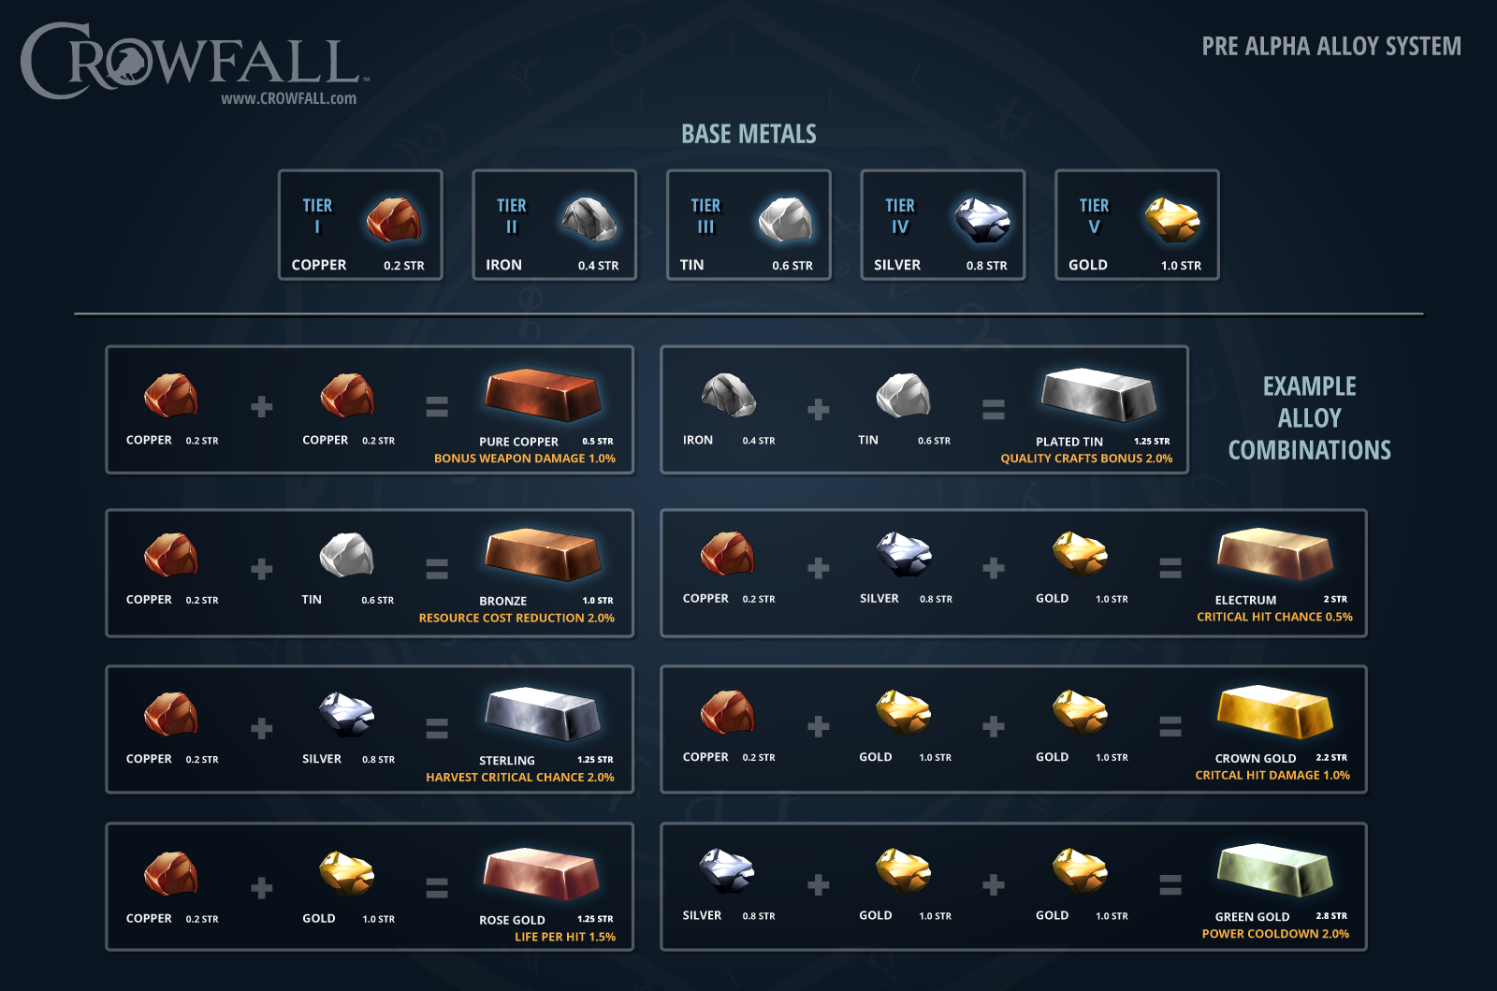

The No Ticono OF Wonderland the ….